Exercise 1: Configuring a Basic Spring Application
Scenario:
Your company is developing a web application for managing a library. You need to use the Spring Framework to handle the backend operations.
Steps:
- Set Up a Spring Project:
  - Create a Maven project named LibraryManagement.
  - Add Spring Core dependencies in the pom.xml file.
- Configure the Application Context:
  - Create an XML configuration file named applicationContext.xml in the src/main/resources directory.
  - Define beans for BookService and BookRepository in the XML file.
- Define Service and Repository Classes:
  - Create a package com.library.service and add a class BookService.
  - Create a package com.library.repository and add a class BookRepository.
- Run the Application:
  - Create a main class to load the Spring context and test the configuration
- Output:
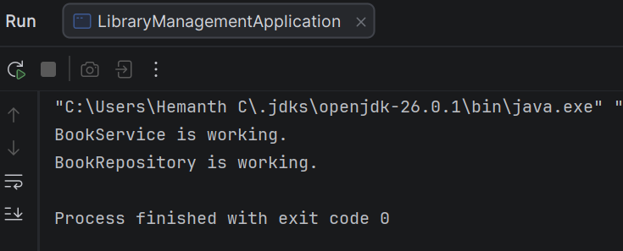

Exercise 2: Implementing Dependency Injection
Scenario:
In the library management application, you need to manage the dependencies between the BookService and BookRepository classes using Spring's IoC and DI.
Steps:
- Modify the XML Configuration:
  - Update applicationContext.xml to wire BookRepository into BookService.
- Update the BookService Class:
  - Ensure that BookService class has a setter method for BookRepository.
- Test the Configuration:
  - Run the LibraryManagementApplication main class to verify the dependency injection.
- Output:
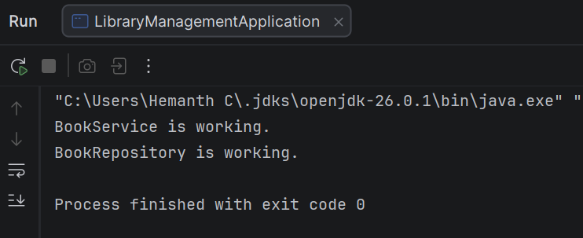

Exercise 4: Creating and Configuring a Maven Project
Scenario:
You need to set up a new Maven project for the library management application and add Spring dependencies.
Steps:
- Create a New Maven Project:
  - Create a new Maven project named LibraryManagement.
- Add Spring Dependencies in pom.xml:
  - Include dependencies for Spring Context, Spring AOP, and Spring WebMVC.
- Configure Maven Plugins:
  - Configure the Maven Compiler Plugin for Java version 1.8 in the pom.xml file.
Output:
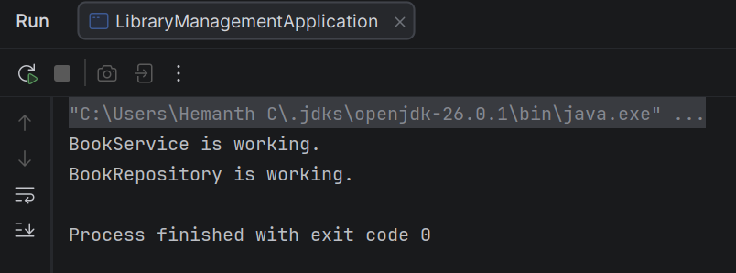

Exercise 5: Configuring the Spring IoC Container
Scenario:
The library management application requires a central configuration for beans and dependencies.
Steps:
- Create Spring Configuration File:
  - Create an XML configuration file named applicationContext.xml in the src/main/resources directory.
  - Define beans for BookService and BookRepository in the XML file.
- Update the BookService Class:
  - Ensure that the BookService class has a setter method for BookRepository.
- Run the Application:
  - Create a main class to load the Spring context and test the configuration.
- Output:
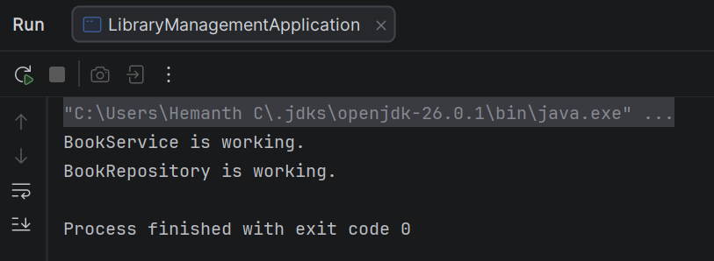

Exercise 7: Implementing Constructor and Setter Injection
Scenario:
The library management application requires both constructor and setter injection for better control over bean initialization.
Steps:
- Configure Constructor Injection:
  - Update applicationContext.xml to configure constructor injection for BookService.
- Configure Setter Injection:
  - Ensure that the BookService class has a setter method for BookRepository and configure it in applicationContext.xml.
- Test the Injection:
  - Run the LibraryManagementApplication main class to verify both constructor and setter injection.
- Output:
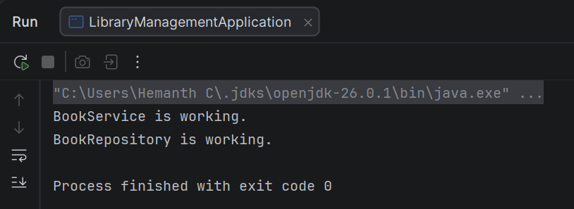

Exercise 3: Implementing Logging with Spring AOP
Scenario:
The library management application requires logging capabilities to track method execution times.
Steps:
- Add Spring AOP Dependency:
  - Update pom.xml to include Spring AOP dependency.
- Create an Aspect for Logging:
  - Create a package com.library.aspect and add a class LoggingAspect with a method to log execution times.
- Enable AspectJ Support:
  - Update applicationContext.xml to enable AspectJ support and register the aspect.
- Test the Aspect:
  - Run the LibraryManagementApplication main class and observe the console for log messages indicating method execution times.

Exercise 6: Configuring Beans with Annotations
Scenario:
You need to simplify the configuration of beans in the library management application using annotations.
Steps:
- Enable Component Scanning:
  - Update applicationContext.xml to include component scanning for the com.library package.
- Annotate Classes:
  - Use @Service annotation for the BookService class.
  - Use @Repository annotation for the BookRepository class.
- Test the Configuration:
  - Run the LibraryManagementApplication main class to verify the annotation-based configuration.
Exercise 8: Implementing Basic AOP with Spring
Scenario:
The library management application requires basic AOP functionality to separate cross-cutting concerns like logging and transaction management.
Steps:
- Define an Aspect:
  - Create a package com.library.aspect and add a class LoggingAspect.
- Create Advice Methods:
  - Define advice methods in LoggingAspect for logging before and after method execution.
- Configure the Aspect:
  - Update applicationContext.xml to register the aspect and enable AspectJ auto-proxying.
- Test the Aspect:
  - Run the LibraryManagementApplication main class to verify the AOP functionality.

Exercise 9: Creating a Spring Boot Application
Scenario:
You need to create a Spring Boot application for the library management system to simplify configuration and deployment.
Steps:
- Create a Spring Boot Project:
  - Use Spring Initializr to create a new Spring Boot project named LibraryManagement.
- Add Dependencies:
  - Include dependencies for Spring Web, Spring Data JPA, and H2 Database.
- Create Application Properties:
  - Configure database connection properties in application.properties.
- Define Entities and Repositories:
  - Create Book entity and BookRepository interface.
- Create a REST Controller:
  - Create a BookController class to handle CRUD operations.
- Run the Application:
  - Run the Spring Boot application and test the REST endpoints.

